

**PANIMALAR INSTITUTE OF TECHNOLOGY**

**NALAYIATHIRAN**

## TEAM LEADER: SURENDIRA KUMAR N

**TEAM MEMBER**

* **HARSHAVARDHAN C**
* **ELAYABHARATHI N**
* **IYYAPPAN M**

**TITLE: IOT BASED REAL TIME RIVR WATER QUALITY MONITORING AND CONTROL SYSTEM**

### IoT Based Real-time River Water Quality Monitoring System Abstract

River water quality monitoring and control analysis is an interesting project we make it with the help of internet of things. Current water quality monitoring system is a manual system with a monotonous process and is very time-consuming. This paper proposes a sensor-based water quality monitoring system. The main components of Wireless Sensor Network (WSN) include a microcontroller for processing the system, communication system for inter and intra node communication and several sensors. Real-time data access can be done by using remote monitoring and Internet of Things (IoT) technology. Data collected at the apart site can be displayed in a visual format on a server PC with the help of Spark streaming analysis through Spark MLlib, Deep learning neural network models, Belief Rule Based (BRB) system and is also compared with standard values. If the acquired value is above the threshold value automated warning SMS alert will be sent to the agent. The uniqueness of our proposed paper is to obtain the water monitoring system with high frequency, high mobility, and low powered. Therefore, our proposed system will immensely help Bangladeshi populations to become conscious against contaminated water as well as to stop polluting the water.

### Introduction

In this project the main purpose is to monitor and control the quality of river water. The environment around consists of five key elements e.g., soil, water, climate, natural vegetation, and landforms. Among these water is the utmost crucial element for human life. It is also vital for the persistence of other living habitats . Whether it is used for drinking, domestic use, and food production or recreational purposes, safe and readily available water is the need for public health . So it is highly imperative for us to maintain water quality balance. Otherwise, it would severely damage the health of the humans and at the same time affect the ecological balance among other species . Water pollution is a foremost global problem which needs ongoing evaluation and adaptation of water resource directorial principle at the levels of international down to individual wells. It has been studied that water pollution is the leading cause of mortalities and diseases worldwide. The records show that more than 14,000 people die daily worldwide due to water pollution. In many developing countries, dirty or contaminated water is being used for drinking without any proper prior treatment. One of the reasons for this happening is the ignorance of public and administration and the lack of water quality monitoring system which makes serious health issues .

Water quality monitoring has gained more interest among researchers in this twenty-first century. Numerous works are either done or ongoing in this topic focusing on various aspects of it. The key theme of all the projects was to develop an efficient, cost-effective, real-time water quality monitoring system which will integrate wireless sensor network and internet of things . In this research, we monitor the physical and chemical parameters of water bodies inside Chittagong city by using an IoT based sensor network.

### Proposed System

main aim is to develop a system for continuous monitoring of river water quality at remote places using wireless sensor networks with low power consumption, low-cost and high detection accuracy. pH, conductivity, turbidity level, etc. are the limits that are analyzed to improve the water quality. Following are the aims of idea implementation (a) To measure water parameters such as pH, dissolved oxygen, turbidity, conductivity, etc. using available sensors at a remote place. (b) To assemble data from various sensor nodes and send it to

the base station by the wireless channel. (c The) To simulate and evaluate quality parameters for quality control. (d) To send SMS to an authorized person routinely when water quality detected does not match the preset standards, so that, necessary actions can be taken.

The detailed scheme of a water quality monitoring system in shown figure.1

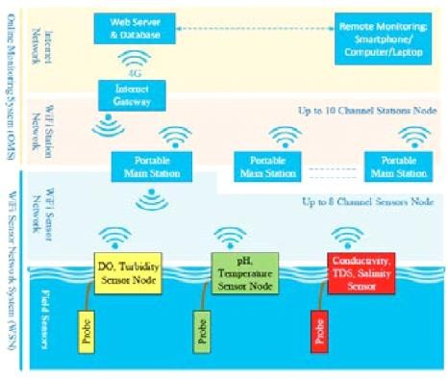

***Sensors for monitoring***

***pH sensor***

The pH of thing is a useful constant to display because graduate and low pH levels can hump large effects on the author. The pH of a statement can grasp from 1 to 14. A pH sensor is an instrumentation that measures the hydrogen-ion density in a bleach, indicating its tartness or alkalinity. Its constitute varies from 0 to 14 pH. Uttermost

pH values also process the solubility of elements and compounds making them cyanogenetic. Mathematically pH is referred as, pH = -log [H+].

### Turbidity Sensor

Turbidity train sensor is victimised to measure the clarity of element or muddiness utter in the water. The muddiness of the open cut food is ordinarily between 255 NTU. Irrigate is visibly at levels above 80 NTU. The standards for intemperance liquid is 130 NTU to 250 NTU. The turbidity device consists of soft sender and acquirer, the transmitter needs to transmit unsubtle

bright, it is said to be turbid. The consequence of turbidity is a reduction in water clarity, aesthetically unpleasant, decreases the rate of photosynthesis, increases water temperature.

#### Temparatur Sensor

Here DS18B20 is old as the temperature device. Usually, its present use to perceive the temperature of the life, if we site the device wrong the conductor electrode and placed into the H2O, it can discover the temperature of H2O also. The normal temperature of the people is (25 -30)°C.

#### Real-time monitoring of water quality by using IoT integrated Big Data Analytics

IoT devices use various types of sensors to collect data about turbidity, ORP, temperature, pH, conductivity, etc. of river water continuously. Also, IoT devices have capability to stream the array of collected data wirelessly to the remote Data Aggregator Server in the cloud. Moreover, the volume of semi structured data increases with time in such a velocity that only the Big Data Analytics applications can efficiently store and analyze the data constantly .

The system should be reliable and scalable. So, data management layer will be deployed and operational on the Apache Hadoop cluster. Hadoop helps distributed storing and processing of big data across cluster of computers. Also, such operational environment is horizontally scalable i.e. nodes or computers can be added to a cluster later while volume and velocity of data streaming will be increasing. Hadoop cluster is fault tolerant as jobs are redirected automatically to the running nodes when nodes are failed. The data in Hadoop is highly available as multiple copies of data are stored in data nodes managed by name node, standby name node, journal nodes and failover controller.

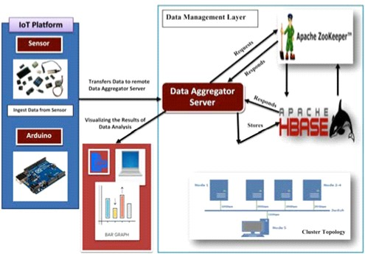

IoT Water Quality Monitor Station and Data Management Layer Architecture ntegration. Turbidity, oxidation reduction potential (ORP), temperature, pH, conductivity, etc. of river water are gathered continuously through IoT devices. IoT devices have capability to stream the array of collected data wirelessly to the remote Data Aggregator Server in the cloud which are efficiently stored and analyzed through the Big Data Analytics applications. Thus, the Data Aggregator Server can retrieve the analysis result and transfer the result to the applications running on smart phones, tablets, laptops, and desktops in the cloud.

#### Result

* 1. , we are displaying the resulting sensed pH, temp, turbidity, and

ORP values. It continuously senses the values of pH, temp, turbidity, and ORP and the resulting values are displayed to the LCD, PC or mobile in real-time. If the acquired value is above the threshold value comments will be displayed as ‘BAD’. If the acquiredvalue is lower than the threshold value comments will be displayed as ‘GOOD’. A bar/line graph will also be shown for perfect understanding.

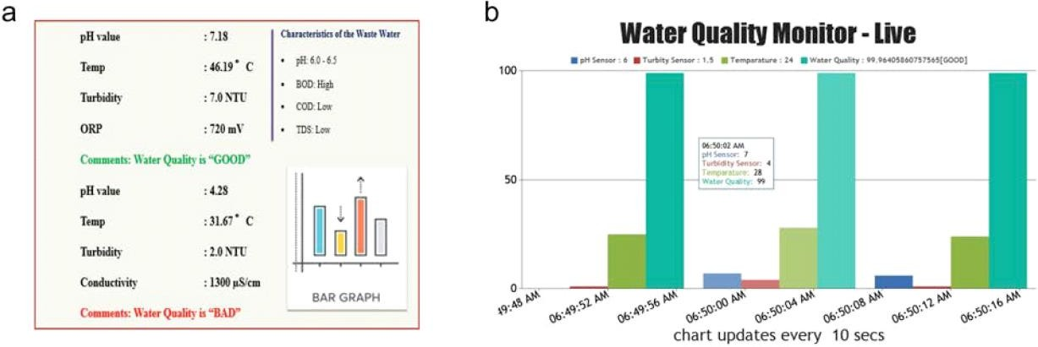

* + 1. The figure displays the resulting sensed pH, temp, turbidity, and ORP values. It continuously senses the values of pH, temp, turbidity, and ORP and the resulting values are displayed to the LCD, PC or mobile in real-time. If the acquired value is above the threshold value comments will be displayed as ‘BAD’. If the acquired value is lower than the threshold value comments will be displayed as ‘GOOD’. A bar/line graph will also be shown for perfect understanding. (b) The time series representation of sensor data with decision.

### Conclusions and future works

Real-time monitoring of water quality by using IoT integrated Big Data Analytics will immensely help people to become conscious against using contaminated water as well as to stop polluting the water. The research is conducted focusing on monitoring river water quality in real-time. Therefore, IoT integrated big data analytics is appeared to be a better solution as reliability, scalability, speed, and persistence can be provided. During the project development phase an intense comparative analysis of real-time analytics technologies such as Spark streaming analysis through Spark MLlib, Deep learning neural network models, and Belief Rule Based (BRB) system will be conducted. This research would recommend conducting systematic experimentation of the proposed technologies in diverse qualities of river water in Bangladesh.

Due to the limitation of the budget, we only focus on measuring the quality of river water parameters. This project can be extended into an efficient water management system of a local area. Moreover, other parameters which wasn’t the scope of this project such as total dissolved solid, chemical

oxygen demand and dissolved oxygen can also be quantified. So the additional budget is required for further improvement of the overall system.

### References

* K. S. Adu-Manu, C. Tapparello, W. Heinzelman, F. A. Katsriku, and J.-D. Abdulai, "Water quality monitoring using wireless sensor networks: Current trends and future research directions," ACM Transactions on Sensor Networks (TOSN), 2017.
* B. Chen, Y. Song, T. Jiang, Z. Chen, B. Huang, and B. Xu, "Real-time estimation of population exposure to PM2.5 using mobile- and station-based big data," Int J Environ Res Public Health*,*Mar 23 2018.
* M. Z. Abedin, A. S. Chowdhury, M. S. Hossain, K. Andersson, and R. Karim, "An Interoperable IP based WSN for Smart Irrigation Systems", presented at the 14th Annual IEEE Consumer Communications & Networking Conference, Las Vegas, 8-11 January 2017, 2017.
* M. Z. Abedin, S. Paul, S. Akhter, K. N. E. A. Siddiquee, M. S. Hossain, and

K. Andersson, "Selection of Energy Efficient Routing Protocol for Irrigation Enabled by Wireless Sensor Networks", in Proceedings of 2017 IEEE 42nd Conference on Local Computer Networks Workshops, 2017.

* M. S. Hossain, S. Rahaman, R. Mustafa, and K. Andersson, "A belief rule- based expert system to assess suspicion of acute coronary syndrome (ACS) under uncertainty", Soft Computing - A Fusion of Foundations, Methodologies and Applications, 2018.

### ­­